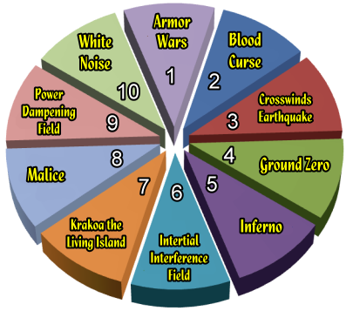**1. Armor Wars**

*When damage dealt is reduced by any power or effect, increase the damage dealt by 1 after it is reduced by all other game effects.*

**2. Blood Curse**

*For each character that KOs or eliminates one or more opposing characters during a turn, roll a d6 at the end of the turn. On a result of 1-3, that character is dealt 1 damage.*

**3. Crosswinds / Earthquake**

* *Characters with the wing speed symbol gain Earthbound. This ability may not be countered.*
* *At the beginning of each player’s turn, that player rolls two six-sided dice. If the combined result is 2-3, remove this Earthquake from the game. Characters without the wing speed symbol are each dealt 3 damage.*

**4. Ground Zero**

*Whenever a character makes a successful close combat attack, roll a six-sided die before damage is dealt. On a result of 5 or 6, the attack deals 1 additional damage. On a result of 1 or 2, after the attack resolves the attacking character is dealt 1 unavoidable damage.*

**5. Inferno**

*At the beginning of your turn, deal 1 damage to each friendly character occupying hindering terrain not generated by powers or abilities.*

**6. Inertial Interference Field**

*When a character makes an attack using Running Shot, Charge, or Hypersonic Speed, reduce damage dealt by 2. Knockback damage is reduced by 1.*

**7. Krakoa the Living Island**

*Once at the end of each player’s turn, he or she can choose a target opposing character adjacent to an unoccupied square of outdoor hindering, blocking, or elevated terrain and make an attack roll with an attack value of 9 and a damage value of 2 against the target; the target can’t be knocked back by the attack. If the attack succeeds but the character target takes no damage from the attack and has zero or one action token, give the target an action token.*

**8. Malice**

*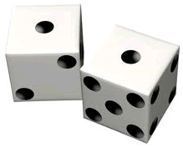At the end of each player’s turn, if none of his or her characters made an attack against an opposing character, that player chooses a friendly character and deals it 1 unavoidable damage.*

**9. Power Dampening Field**

*Damage values higher than 3 become 3 instead.*

**10. White Noise**

*When a character is the target of Outwit or Perplex, its controller rolls one six-sided die. On a result of 4-6, the target ignores that use of Outwit or Perplex.*

**If using a 12-sided Dice, the following applies:**

**11. Ouch! Ouch! Ouch!**

*All figures on the board take 1 unavoidable damage!*

**12. Really Bad Luck**

*Each player rolls the dice once, and both results apply. When making this extra roll, “12” is treated as an “11”.*